# Artistic Effects

## Question: 1

How would I change Tracy’s trail to a yellow line with a thickness of 10 pixels?

Color(Yellow)

thickness(10)

color(“yellow”)

pensize(10)

color yellow()

pensize(10)

color yellow():

pensize(10)

## Question: 2

What is true of Tracy’s color command?

You can only use hex color codes

There are 10 different colors that Tracy knows

The color name must have underscores between words (ex: light_blue)

The color name must be in quotation marks

## Question: 3

What is the correct way to draw a circle that is filled in?

begin_fill()

circle(20)

end_fill()

circle(20)

begin_fill()

end_fill()

circle(begin_fill, 20, end_fill)

circle(20)

end_fill()

## Question: 4

What would be the output of the following commands?

circle(50,360,5)

1. 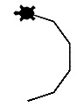
2. 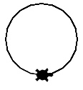
3. 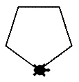
4. 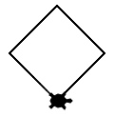

## Question: 5

What would be the output of the following commands?

circle(50,180,3)

1. 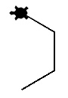
2. 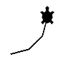
3. 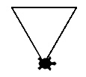
4. 